How to Access Clever from Home

Using your preferred browser go to www.spokaneschools.org and click on “Schools”
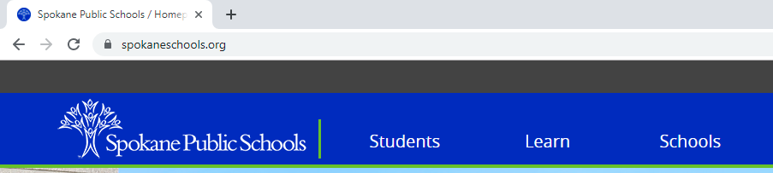

From the drop down menu select “Middle: 7&8”
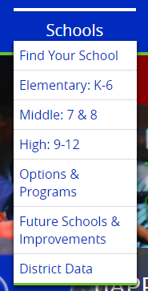

Scroll down on the Middle 7&8 page until you see Garry and click on “Garry”
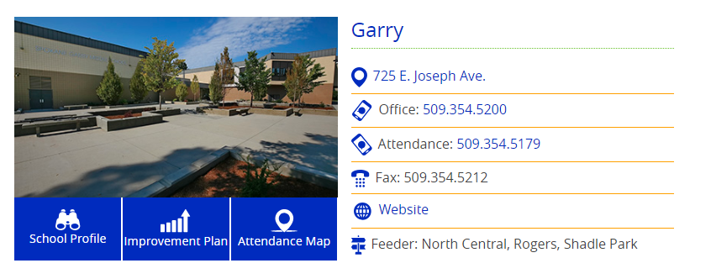

Again scroll down a little bit so you can see all the icons under the picture. Then click on “Digital Tools”
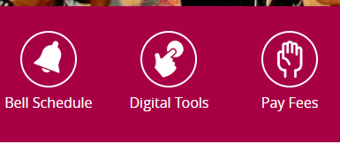

In the Online Learning section click on “Clever”
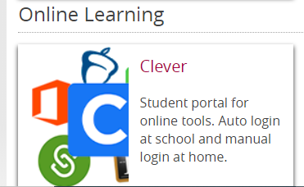

Students will click “Log in with your District Account”. Students will log in to their District Account with their Office365 username and their eight-digit birthdate (MMDDYYYY). For reference, students’ Office 365 username is their Last Name + last 4 digits of their student ID followed by @sps81.org.
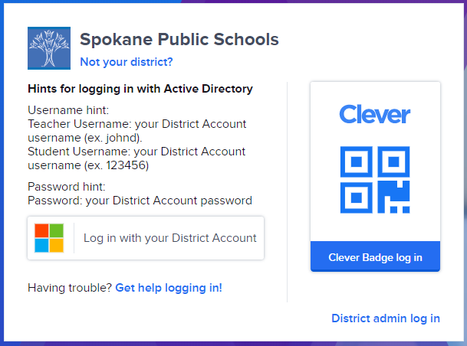

Once in Clever look for the MobyMax icon and click on it.

