2022-2023
Spokane Public Schools
Elementary Supply List

General classroom supplies such as pencils, glue, crayons, scissors, markers and tissue are provided by the school district.
The following are recommended for students to bring to school.
*Supply quantities requested for
Audubon students only

Kindergarten – Grade 2
Headphones for computer use
Change of Clothes
Gym shoes for Fitness & Health
Backpack with student name clearly printed inside- (large enough to fit a folder)
1 tissue box
Change of clothes for emergencies (Grades K-1)

Grade 3
Headphones for computer use
Pencil Box
__1__ Composition notebook
(wide ruled)
1 package 8-12 colored pencils
Gym shoes for Fitness & Health
Backpack with student name clearly printed inside

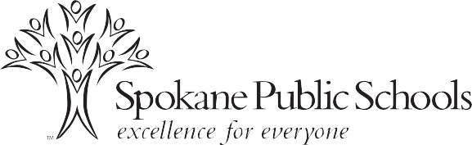

Grade 4
Headphones for computer use
Pencil Box
___1__Composition notebook
1 package subject dividers for 3-ring binder
1 package 8-12 colored pencils
Gym shoes for Fitness & Health
Backpack with student name clearly printed inside

Grade 5
Headphones for computer use
Pencil Box
____1_3-ring binder 2”
__1___Notebook paper – College Ruled
___1__ Composition notebooks
___1__Spiral notebook, 8.5”x11”, 70-sheet
_1 pkg_blue/black pens
__1 pkg highlighters
1 package subject dividers for 3-ring binder
Pencil/supply pouch to place inside 3-ring binder
12-inch ruler with centimeters and inches
1 package 8-12 colored pencils
Gym shoes for Fitness & Health
Backpack with student name clearly printed inside

