2023-2024
Spokane Public Schools
Elementary Supply List

General classroom supplies such as pencils, glue, crayons, scissors, markers, and tissue are provided by the school district.
The following are recommended for students to bring to school.

Balboa Students Only

Kindergarten – Grade 2

- Headphones (over the ear) for computer use
- Pencil Box (1st & 2nd only)
- Gym shoes for Fitness & Health
- Backpack with student name clearly printed inside

Grade 2/3 combo & 3rd

- Headphones for computer use
- Pencil Box
- 2 - Spiral notebook, 8.5”x11”, 70-sheet (wide ruled)
- Gym shoes for Fitness & Health
- Backpack with student name clearly printed inside
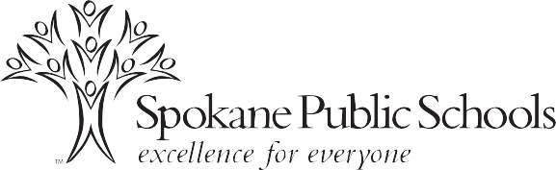

Grade 4 and Grade 5

- Headphones for computer use
- 3-ring binder 2 - 3 inch (zipper preferred)
- 2 - Spiral notebooks, 8.5"x11", 70-sheet - college rule
- 2 - Thin yellow highlighters
- 1 - Package subject dividers for 3-ring binder
- 1 - Pencil/supply pouch to place inside 3-ring binder (if not included with binder)
- 1 - Package 12 colored pencils
- Gym shoes for Fitness & Health
- Backpack with student name clearly printed inside

