Date Completed: Parent/Guardian Initial:

Do you have any visual problems? Yes No

Do these symptoms worsen with:

• Physical Activity: Yes No Not applicable

• Thinking/Cognitive Activity: Yes No Not applicable

Daily activity level _____ % of normal.

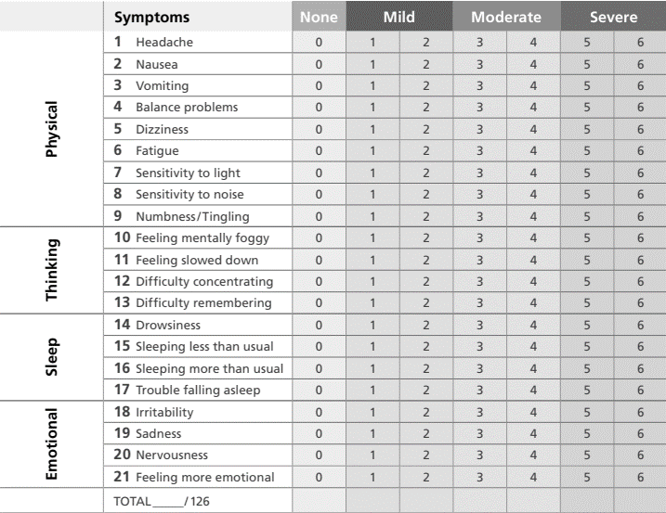

Date Completed: Parent/Guardian Initial:

Do you have any visual problems? Yes No

Do these symptoms worsen with:

• Physical Activity: Yes No Not applicable

• Thinking/Cognitive Activity: Yes No Not applicable

Daily activity level _____ % of normal.

Date Completed: Parent/Guardian Initial:

Do you have any visual problems? Yes No

Do these symptoms worsen with:

• Physical Activity: Yes No Not applicable

• Thinking/Cognitive Activity: Yes No Not applicable

Daily activity level _____ % of normal.

Date Completed: Parent/Guardian Initial:

Do you have any visual problems? Yes No

Do these symptoms worsen with:

• Physical Activity: Yes No Not applicable

• Thinking/Cognitive Activity: Yes No Not applicable

Daily activity level _____ % of normal.