Vocabulary for the German Unification and Italian Unification (Nationalism)
The following words are introduced or reinforced in this lesson. Reference the unit vocabulary tracker for more information.
Word/Phrase  (part of speech) | Definition
Austrian Empire (n.) | (1804-1919) an empire in Central Europe
blood and iron policy (n.) | Otto von Bismarck’s policy for unifying Germany through war
Camillo di Cavour (n.) | (1810-1861) a politician and Prime Minister of the Kingdom of Piedmont-Sardinia in Northern Italy and later Prime Minister of Italy who was a leader of the Italian unification movement
Congress of Vienna (n.) | (1815) meeting of representatives from powerful states in Europe to redraw the map of Europe to restore it to pre-Napoleon conditions and to establish a balance of power that will prevent future wars
French Revolution (n.) | (1789-1799) a political revolution during which the lower and middle class in France, frustrated over social, economic, and political problems in the country and inspired by Enlightenment ideas overthrew King Louis XVI and tried to institute a more democratic government
German Confederation (n.) | (1815-1848) a group of 39 German-speaking states in Central Europe created by the Congress of Vienna to replace the Holy Roman Empire which ended as a result of the Napoleonic Wars
Giuseppe Garibaldi (n.) | (1807-1882) a general and Italian nationalist who was a leader of the Italian unification movement
Giuseppe Mazzini (n.) | (1805-1872) a politician, journalist and Italian nationalist who was a leader of the Italian unification movement
King Wilhelm I (n.) | (1797-1888) King of Prussia and later German Emperor who was a leader of German unification
Napoleon Bonaparte (n.) | military leader and later emperor of France who brought order and stability towards the end of the Revolution. He attempted to conquer all of Europe, but failed and was eventually exiled to a remote island for the rest of his life
Napoleonic Wars (n.) | (1803-1815) a series of major wars in Europe during which Napoleon Bonaparte I attempted to conquer the continent, after his final defeat Napoleon was exiled to an island in the Atlantic Ocean and European powers redrew the borders in the continent at the Congress of Vienna
nationalism (n.) | strong feelings of support for one's nation
nationalistic (adj.) | having strong feelings of support for one’s nation
Otto Von Bismarck (n.) | (1815-1898) a politician who was Minister President of Prussia and later Imperial Chancellor of the German Empire who was a leader of German unification. He practiced a policies called realpolitik and “Blood and Iron.”
Ottoman Empire (n.) | (1299-1922) a predominantly Muslim empire that controlled much of the Middle East, Southeast Europe, and North Africa and was dissolved after defeat in World War I
realpolitik (n,) | a political philosophy that states that the circumstances of a situation and outcomes of one’s actions are more important than ideas and morals
Victor Emmanuel II (n.) | (1820-1878) King of Sardinia, a state in Northern Italy and later King of Italy who was a leader of the Italian unification movement
Objective: | What historical circumstances led to the unification of Germany and Italy?  - Explain the historical circumstances that led to the unification of Germany and Italy.

Introduction
➡Directions: Examine the two maps below, then answer the questions that accompany them.
Map A  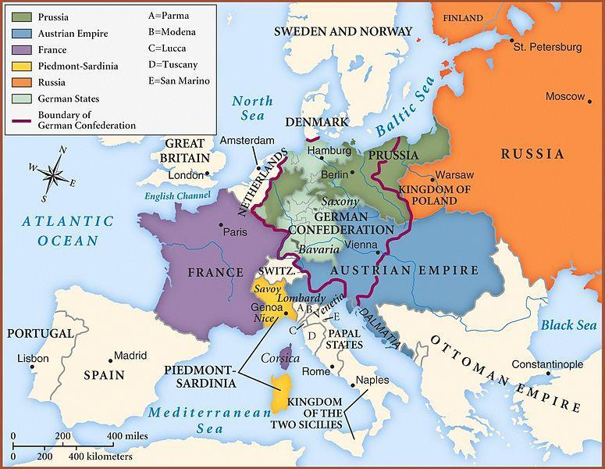  Map of Europe after the Congress of Vienna, 1815.  Image is courtesy of wikimedia commons | 1. In 1815, what two empires existed in Europe?  2. The German Confederation was an association of 39 German states in Central Europe, created by the Congress of Vienna in 1815. The Congress of Vienna coordinated the economies of separate German-speaking countries and replaced the former Holy Roman Empire. According to the map, how would the establishment of the German Confederation impact existing empires and states?  3. Locate the Italian peninsula. It looks like a boot that juts into the Mediterranean Sea. How many different states/kingdoms control sections of the Italian peninsula?

Map B  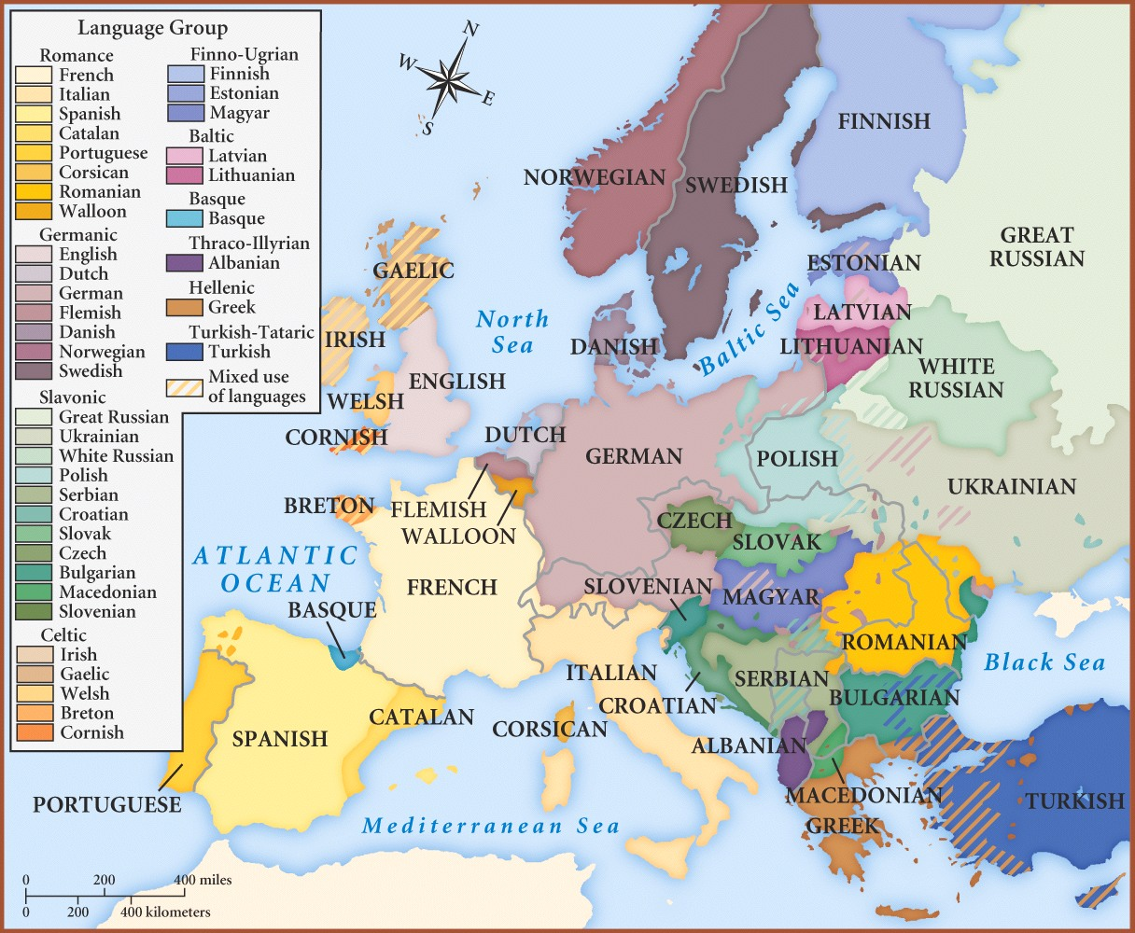  Map of Language Groups in Europe, 1910  Image is courtesy of wikimedia commons and is in the public domain | 4. What is the purpose of Map B?  5. Based on both maps, which language(s) were spoken in France? Spain? Why do you think this was?  6. Which languages were spoken in the Austrian Empire?  7. Which languages were spoken in the Ottoman Empire?  8. Which states (empires, countries, kingdoms, etc) controlled land where people spoke German the most?  9. Which states controlled land where people spoke Italian the most?
10. Based on both maps, which areas are most likely to be pulled together by nationalism? Why?

11. Which states are most likely to be pulled apart by nationalism? Why?

Contextualize | Connect Cause and Effect | The Impact of the French Revolution and Napoleon on European Nationalism  ➡Directions: Read the text and examine the map below, then answer the question that accompanies them.

The French Revolution (1789–1799) was a period of political and social upheaval in France and Europe, during which the French government, previously an absolute monarchy, underwent radical changes based on Enlightenment principles of republic, citizenship, and inalienable rights.  This revolution sparked five wars between the well-trained armies of Napoleon Bonaparte, Emperor of France, and neighbors including Prussia and Austria called the Napoleonic Wars. From 1803 to 1814, Napoleon ruled over a large section of Europe. During that time he and the ideals of the French Revolution greatly affected the regions he controlled. The revolution’s nationalistic call for “liberty, equality, and fraternity” and a government ruled by the will of the French people, instead of a royal family with connections outside of France, inspired similar feelings in regions occupied by Napoleon’s troops.  In central Europe, for example after conquering the area, Napoleon created the German Confederation, an association of German speaking states that were previously part of the Holy Roman Empire, Prussia, and the Austrian empire. Soon after Napoleon was defeated, the German Confederation was dismantled. At the Congress of Vienna (1815) the major European powers decided to give the land back to Prussia and the Austrian Empire, but the idea of unity for German speaking people remained.  The French Revolution and Napoleon affected people living on the Italian peninsula as well. Napoleon ruled the entire area as the Napoleonic Kingdom of Italy. His reign inspired nationalistic feelings in the Italians. As happened to the German Confederation, the Kingdom of Italy was broken up after Napoleon’s defeat. The representatives at the Congress of Vienna divided Italy up into small independent governments and gave the Austrian Empire control of Northern Italy. Austrian Chancellor Franz Metternich, an influential diplomat at the Congress of Vienna, stated that the word Italy was nothing more than "a geographic expression."  Though Napoleon was defeated, the nationalism that he and the French Revolution inspired lingered in German and Italian speaking regions, threatening the Austrian Empire. | 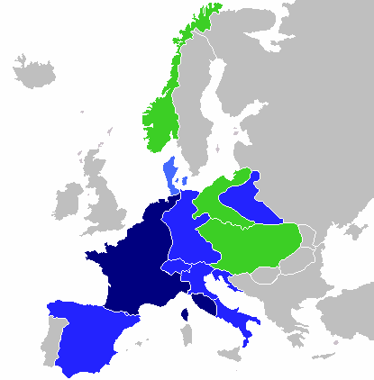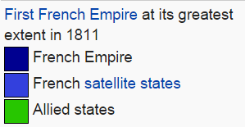  Image is courtesy of wikimedia commons
 | 1. What effects did the French Revolution and Napoleon's rule have on the German and Italian speaking people in Europe?

Contextualize | Connect Cause and Effect | German Unification (1861-1871)  ➡Directions: read through the text and examine the image below, then answer the questions that follow.
Photograph of Otto von Bismarck in 1881  Image is courtesy of wikimedia commons |  | By the mid-1800s, Prussia had been a force in politics in Northern Europe for centuries. Like most of Europe, it was conquered by Napoleon in the early 1800s and was a part of the coalition of countries who defeated him in 1814.  In 1861, King Wilhelm I, a supporter of German unity, came to power. In 1862, he appointed Otto von Bismarck (1815–1898) the new Prime Minister of Prussia. Bismarck became known for his style of diplomacy known as realpolitik. Realpolitik is also known as “pragmatism” and is a way of making political decisions based on being practical instead of based on ideals. Bismarck argued that Germany could only unify through a foreign policy called “blood and iron,” meaning through war and military strength.  Through a series of wars against Denmark, Austria, and France, Prussia led by Wilhelm I and Otto von Bismarck conquered most of the German speaking areas of Europe. On January 18, 1871, the German princes assembled in the Hall of Mirrors of the Palace of Versailles after defeating France and proclaimed the Prussian King Wilhelm I as the "German Emperor" on January 18, 1871. The German Empire was thus founded.  Source: “Germany.” New World Encyclopedia. http://www.newworldencyclopedia.org/entry/Germany  Questions  1. Who were the two leaders of Prussia that led the unification of Germany?  2. Describe Otto von Bismarck’s policy called realpolitik. How was realpolitik different from the way Maximilien Robespierre led during the French Revolution?  3. According to Bismarck’s “blood and iron” policy, how was Prussia going to unite the German-speaking people?  4. Which countries did Prussia go to war with to gain control of the German speaking areas in Europe?
Timeline of German Unification
1861 | King Wilhelm I of Prussia comes to power
1862 | Wilhelm I appoints Otto von Bismarck as Minister-President of Prussia
1864 | Danish War-
1866 | Austro-Prussian War
1870-1871 | Franco-Prussian War
1/18/1871 | German Empire is proclaimed, unifying Germany

Contextualize | Connect Cause and Effect | Italian Unification (1849-1878)  ➡Directions: read through the text and examine the images and maps below, then answer the questions that follow.

Timeline of Italian Unification |  | The Soul, The Brain, and the Sword of Italian Unification  Giuseppe Mazzini, “The Soul” Image is courtesy of wikimedia commons Camillo Cavour, “The Brain” Image is courtesy of wikimedia commons Giuseppe Garibaldi, “The Sword” Image is courtesy of wikimedia commons
1849 | Victor Emmanuel II becomes king of Sardinia
1852 | Count Cavour becomes prime minister of Piedmont
1860 | Giuseppe Garibaldi’s invasion of the Two Sicilies
3/17/1861 | Kingdom of Italy is proclaimed
1866 | Italy annexes Venetia
1870 | Italy annexes Rome, uniting all of the Italian peninsula
After Napoleon Bonaparte’s empire crumbled, the representatives at the Congress of Vienna decided to award most of northern Italy to the Austrian Empire and to give several monarchs control over the rest of the Italian peninsula instead of unifying them. Despite the Austrian Empire’s attempts to suppress it, nationalism inspired by the French Revolution took hold of the Italians.

Revolutionary groups formed in Italy and tried to organize the people into revolt. Giuseppe Mazzini, who was later known as “the soul” of Italian unification, was a part of one of the most influential groups, known as the Carbonari, that created a secret organization called Young Italy in 1831. In southern Italy, another member of the Carbonari, a general named Giuseppe Garibaldi gathered nationalistic volunteers called red shirts to fight with him against the Austrian Empire and those Italian monarchs who did not want to unify Italy. Between 1814 and 1849, the rebellions started by nationalist organizations like those led by Mazzini and Garibaldi were stamped down by local forces or Austrian troops. As a result, both Mazzini and Garibaldi were exiled for their revolutionary actions. They returned when leaders in northern Italy started a campaign that eventually brought Italy together.

In 1849, Victor Emmanuel II, a supporter of Italian unification, became the King of Sardinia in the Piedmont region of northern Italy. Camillo di Cavour, an experienced and savvy diplomat, became Emmanuel’s president of the Council of Ministers in 1852. Emmanuel and Cavour, with the help of Napoleon III of France, used Piedmontese and French troops to successfully pushed the Austrians out of Northern and Central Italy, expanding the Kingdom of Sardinia to a large amount of the Italian peninsula by 1859.

Garibaldi, who had returned to Italy to aid in the unification, was convinced by Cavour in May of 1860 to concentrate his forces on Sicily where recent rebellions demonstrated that there was support for their cause. Garibaldi and about a thousand red shirts conquered Sicily in three days. Garibaldi went on to attack several other cities and invaded Naples, gaining support from the inhabitants and becoming a national hero in the process.

Meanwhile, Victor Emmanuel commanded the Sardinian army to march south, defeating the Papal states, and coming to Garibaldi’s aid. Garibaldi gave over his command to Emmanuel and they defeated the king of Naples. Only Rome and Venetia remained. On February 18, 1861, Victor Emmanuel assembled the deputies of the first Italian Parliament in Turin. On March 17, 1861, the Parliament proclaimed Victor Emmanuel II King of Italy.

Three months later, Cavour, having seen his life's work nearly complete, died. When he was given the last rites, Cavour purportedly said: "Italy is made. All is safe.”

By 1871 both Venetia and Rome came under the control of the Italian government. Venetia was won because the Italians sided with the Prussians in the Prusso-Austrian War in 1866 and Rome was taken by force when French troops left the city to defend France against Prussia in 1870.

Source: Adapted from “Italian Unification.” New World Encyclopedia. http://www.newworldencyclopedia.org/entry/Italian_unification
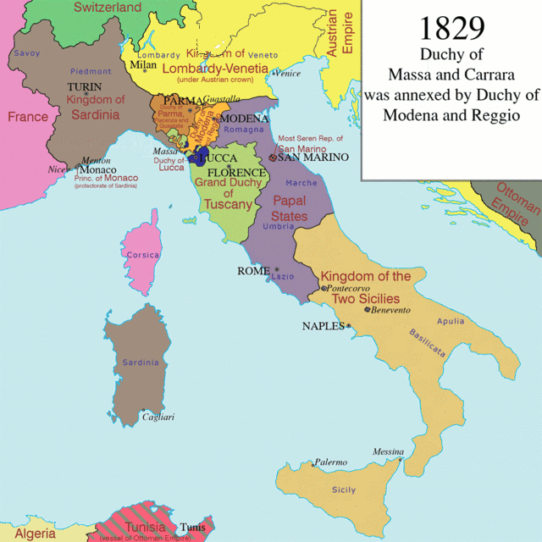 | 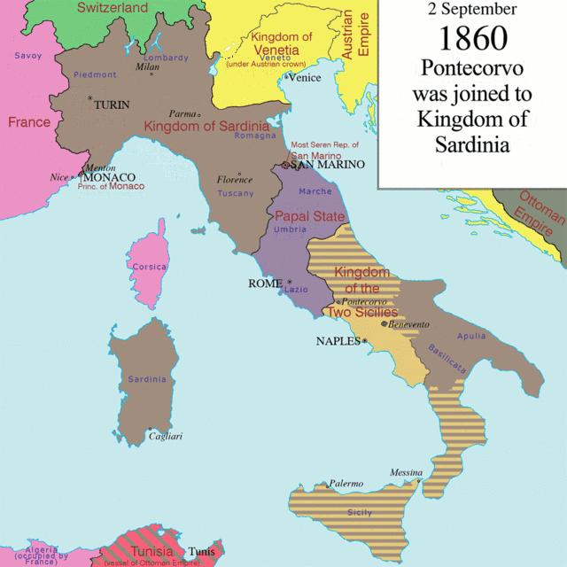 | 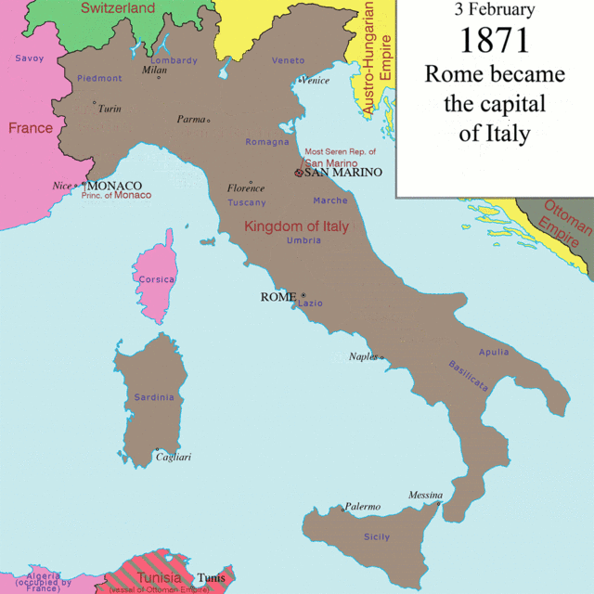
Image created by Artemka is licensed under the Creative Commons Attribution-Share Alike 3.0 Unported license.
1. Identify the four most important leaders of Italian unification. | 2. Which countries/empires did the Italians have to fight or make deals with to gain control of the entire Italian peninsula?

 | What historical circumstances led to the unification of Germany and Italy?
Connect Cause and Effect | ➡ Directions: Based on what you have learned, complete the task below to describe how the Mongol Empire gained, consolidated, and maintained power in Asia.  Example: The Mongol Empire gained, consolidated, and maintained power throughout Asia during the 13th century.  Who? individuals, groups of people, regions, nations involved Mongol Empire  When? date, year, era, “before __,” “after __” 13th century  Where? continents, regions, countries, geographic features nearby, describe the geography if relevant Asia and Eastern Europe  How? describe the process that took place Repeated military campaigns, superior weaponry, religious toleration for conquered people  Combined Contextualization: Example 1 Why did it happen when and where it happened? Throughout the 13th century, the Mongol Empire which stretched across Eastern Europe and most of Asia gained, consolidated, and maintained power by using repeated military campaigns, superior weaponry, and implementing religious toleration for conquered people. Writing Strategies Used: Prepositional phrase (Throughout the 13th century,) Conjunctions (by, and)  Combined Contextualization: Example 2 Why did it happen when and where it happened? The Mongol Empire, a state that stretched across Eastern Europe and most of Asia in the 13th century, maintained power by using repeated military campaigns, superior weaponry, and implementing religious toleration for conquered people. Writing Strategies Used: Appositives (..., a state that stretched across Eastern Europe and most of Asia in the 13th century,...) Conjunctions (by, and)  Content and Vocabulary Checklist  Use the checklist below to assess the use of important content and vocabulary in the unit.  Self Yes/No Teacher Yes/No Did you use the content and vocabulary below in your response?  language  Napoleon  nation, nationalism  unify  war  Event: The Unification of Italy OR Germany (CHOOSE 1)  Who?  individuals, groups of people, regions, nations involved  When?  date, year, era, “before __,” “after __”  Where?  continents, regions, countries, geographic features nearby, describe the geography if relevant  How?  describe the process that took place  Why?  use words and phrases like “led to,” because, and so to show connections between events and to explain why  Combined Contextualization  Why did it happen when and where it happened?

