2023-2024
Spokane Public Schools
Elementary Supply List

General classroom supplies such as pencils, glue, crayons, scissors, markers and tissue are provided by the school district.
The following are recommended for students to bring to school.
*Supply quantities requested for
Franklin Elementary students only

Kindergarten – Grade 2
Headphones for computer use
Gym shoes for Fitness & Health
Backpack with student name clearly printed inside

Grade 3
Headphones for computer use
Gym shoes for Fitness & Health
Backpack with student name clearly printed inside

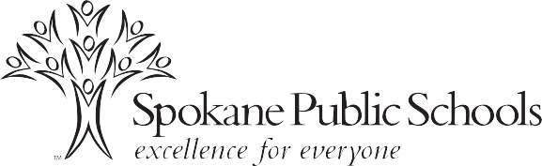

Grade 4
Headphones for computer use
Pencil Box
2 packages Notebook paper – Wide Ruled *
3 Composition notebooks – Wide Ruled *
1 package 8 – 12 colored pencils
Gym shoes for Fitness & Health
Backpack with student name clearly printed inside

Grade 5
Headphones for computer use
Pencil Box
1 1/2” 3-ring binder *
1 package Notebook paper – College Ruled *
2 Composition notebooks *
3 Portfolio folders with pockets, 3-hole *
1 package subject dividers for 3-ring binder
Pencil/supply pouch to place inside 3-ring binder
12-inch ruler with centimeters and inches
1 package 8-12 colored pencils
Gym shoes for Fitness & Health
Backpack with student name clearly printed inside

