2023-2024

Spokane Public Schools Elementary Supply List

General classroom supplies such as pencils, glue, crayons, scissors, markers and tissue are provided by the school district.
The following are recommended for students to bring to school.

Grade 4
Headphones for computer use Pencil Box
3-ring binder (School, please specify inch
size if requiring)

*Supply quantities requested for Notebook paper – Wide Ruled
students only Composition notebooks
(School Name) Portfolio folders with pockets, 3-hole
1 package subject dividers for 3-ring binder

Kindergarten – Grade 2
Headphones for computer use Pencil Box
Gym shoes for Fitness & Health
Backpack with student name clearly printed inside

Grade 3
Headphones for computer use Pencil Box
Pencil/supply pouch to place inside 3-ring binder 1 package 8-12 colored pencils
Gym shoes for Fitness & Health
Backpack with student name clearly printed inside

Grade 5
Headphones for computer use 1 Composition Notebook

3-ring binder (School, If needed for AVID 1 Spiral Notebook, 8.5”x11”, 70-sheet

work, please specify inch size or delete) *

Composition notebooks * 12-inch ruler with centimeters and inches
Spiral notebooks, 8.5”x11”, 70-sheet * 1 package 8-12 colored pencils

(School, please specify wide or college-ruled) 1 package 8-12 colored pencils
Gym shoes for Fitness & Health
Backpack with student name clearly printed inside

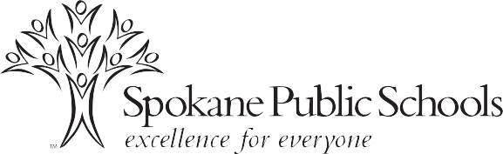
1 package of markers
Gym shoes for Fitness & Health
Backpack with student name clearly printed inside

