2023-2024
Spokane Public Schools
Elementary Supply List

General classroom supplies such as pencils, glue, crayons, scissors, markers and tissue are provided by the school district.
The following are recommended for students to bring to school.
*Supply quantities requested for
________________ students only
Moran Prairie

Kindergarten – Grade 2
Headphones for computer use
Pencil Box
Gym shoes for Fitness & Health
Backpack with student name clearly printed inside

Grade 3
Headphones for computer use
Gym shoes for Fitness & Health
Backpack with student name clearly printed inside

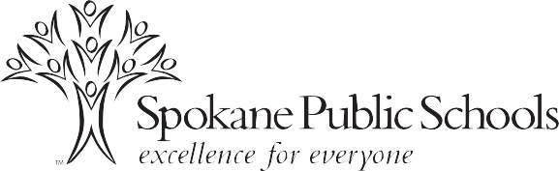

Grade 4
Headphones for computer use
Pencil Box
___1__Notebook paper – Wide Ruled
__3___Composition notebooks
___1__Portfolio folders with pockets, 3-hole

Grades 5
Headphones for computer use
Pencil Box
_____3-ring binder (School, please specify inch size if requiring) *
___1__Notebook paper – College Ruled
_____Composition notebooks
____1_Portfolio folders with pockets
__1___Spiral notebook, 8.5”x11”, 70-sheet
___2__Pens
____2_Highlighters
Pencil/supply pouch to place inside 3-ring binder
12-inch ruler with centimeters and inches
1 package 8-12 colored pencils
Gym shoes for Fitness & Health
Backpack with student name clearly printed inside

