Breaking Down the 2024-25 Pell Look-Up Tables
Tuesday, June 6, 2023
Share |
By Alondra Vallejo, Communications Intern, and Catherine Brown, Senior Director of Policy and Advocacy
Reading time: Seven minutes
Federal Student Aid (FSA) recently released a series of Pell Look-Up Tables to help students better understand their likely Pell Grant award in advance of applying to college. These tables are a critical early awareness tool for National College Attainment Network (NCAN) members, students, and families to use to better understand how much federal grant aid they can expect to receive for college. According to an NCAN analysis, students across the country left $3.58 billion in Pell Grants on the table by not filling out the Free Application for Federal Student Aid (FAFSA) in 2022. The Look-Up Tables should help reduce the number of Pell Grants that go unclaimed each year by making students more aware of the federal student aid to which they are entitled. These tables are particularly important this year – with the FAFSA delayed until December 31 - because they provide a way for students to get an estimate of their Pell Grant long before they can complete the form and receive their official student aid report.
As we continue to approach the opening of the Better FAFSA by December 31, 2023, it’s important that we break down the Pell Look-Up Tables and understand how they can help a student determine their eligibility for a maximum or minimum Pell Grant for the 2024-25 award year. The new formula for determining a student’s Pell Grant eligibility, called the Student Aid Index (SAI), is simpler than the previous one and allows students to estimate in advance whether they will be eligible for a minimum or maximum Grant based on just a few factors. These factors include: a student’s dependency status, state of legal residence, a student and/or parent’s adjusted gross income (AGI), and family size. The Look-Up Tables use the 2022 poverty lines to determine eligibility for a maximum (Max Pell) or minimum (Min Pell) award. The new formula expands access to Pell Grants to students with an:
- AGI less than or equal to 225% of the poverty line (single parent)
- AGI less than or equal to 175% of the poverty line (not a single parent).

The Five Things an Applicant Will Need to Have to Use the Pell Grant Look-Up Tables

1. Dependent or Independent Student Status
Whether someone is a dependent or independent student determines which Look-Up Table to use. There are separate tables for independent and dependent students. To select one, make sure to understand what would qualify someone as a dependent or independent student:
- Independent Student: A student who is either born before January 1, 2001, married, a graduate/professional student, a veteran, a member of the armed forces, an orphan, a ward of the court, someone with legal dependents (not a spouse), an emancipated minor, someone who is or at risk of experiencing homelessness, or a student in a legal guardianship as determined by a court in their state of residence.
- Dependent Student: A student who does not meet any of the criteria for an independent student.

2. State of Legal Residence
The state in which a student lives will dictate which Look-Up Table to use to see if they will qualify for a Pell Grant. There are separate Look-Up Tables for:
- Hawaii
- Alaska
- The 48 other contiguous states and District of Columbia.
The factors and process to evaluate eligibility apply across all the tables.

3. Single Parent Status
After determining a student’s dependency status and their legal residence, they must determine if they are a single parent (if they’re independent) or if their parent (if they’re dependent) is a single parent. This information will help them navigate which part of the Look-Up Table to read to understand their eligibility status.

4. Family Size
The fourth factor students will need to understand to use the Look-Up Table is their family size. It varies based on whether they are a dependent or independent student. Here’s how to determine a student’s family size:
If you are a: | Your household includes:
Dependent student | - You  - Your parents, even if the student is not living with them. Exclude a parent who has died or is not living in the household because of separation or divorce. Include a parent who is active on duty in the US Armed Forces apart from the family.  - The student’s siblings if the following are true:  - They live with the student's parents (or live apart because of college enrollment).  - They receive more than half of their support from the student’s parents.  - They will continue to receive more than half their support from the student’s parents during the award year.  - Other persons if the following are true:  - They will live with the student’s parents.  - They receive more than half of their support from the student’s parents.  - They will continue to receive more than half their support from the student’s parents during the award year.
Independent student | - The student  - The student’s spouse, if applicable.  - The student’s dependent children if the following are true:  - They live with the student.  - They receive more than half of their support from the student.  - They will continue to receive more than half their support from the student during the award year.  - Other persons if the following are true:  - They live with the student.  - They receive more than half of their support from the student.  - They will continue to receive more than half their support from the student during the award year.

5. Adjusted Gross Income (AGI)
A student’s AGI is their/their parent’s gross income minus adjustments to income and can be found on their parent’s (if the student is dependent) or their (if they are independent) tax return. The AGI can be found on Line 11 of Form 1040. An applicant’s AGI is used in the Look-Up Tables to compare the maximum or minimum Pell AGI threshold to determine if a student qualifies for a portion of the grant.

How to Use the Pell Look-Up Tables
After gathering these five key pieces of information you need to read the Look-Up Tables, you’re ready to take the next step! First, identify the right table for you. If you are a dependent student from New York who lives with a single parent, for example, find the table that meets that criterion. If you’re an independent student from Alaska, you’ll need a different table. Once you’ve found the right one, it’s time to get started.
Here are a few examples:

For Dependent Students:
If the student’s parent’s 2022 AGI is greater than $0 and their parent’s 2022 AGI is less than or equal to the Max Pell Parent AGI Limit according to their family size on the look-up table, then you are eligible for a Max Pell.
- Example: For a dependent student living in New York with a family size of four and a single parent’s 2022 AGI of $40,000, the applicant would be eligible for Max Pell (parent’s 2022 AGI of $40,000 is less than Max Pell Single Parent AGI Limit of $62,438).
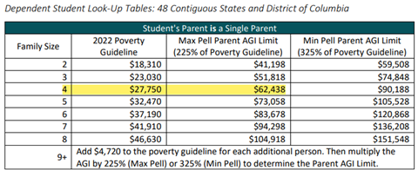
If you are not eligible for a Max Pell and your parent’s 2022 AGI is less than or equal to the Min Pell Parent AGI Limit according to your family size, then you are eligible for at least a Min Pell. Your actual Pell Grant award could be much higher than a Min Pell (but less than a Max Pell). The SAI will determine your precise Pell award.
- Example: For a dependent student living in Pennsylvania, with a family size of five, and not with a single parent whose parent’s 2022 AGI is $80,000 would be eligible for at least a Min Pell (parent’s 2022 AGI of $80,000 is greater than $56,823 but less than $89,293).
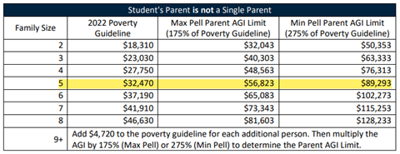

For Independent Students:
If the student’s 2022 AGI is greater than $0 and their 2022 AGI is less than or equal to the Max Pell Student AGI Limitaccording to their family size on the look-up table, then they are eligible for a Max Pell.
- Example: For an independent student who is a single parent living in New York with a family size of four and a 2022 AGI of $40,000, the applicant would be eligible for Max Pell (student's 2022 AGI of $40,000 is less than Max Pell Single Parent Student AGI Limit of $62,438).
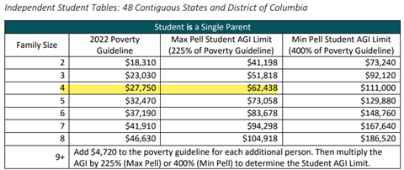
If the student is not eligible for Max Pell and their 2022 AGI is less than or equal to the Min Pell Student AGI Limit according to their family size on the look-up table, they are eligible for at least a Min Pell. Their actual Pell could be between a Min and Max Pell.
- Example: For an independent student, who is a parent but not a single parent, living in Pennsylvania with a family size of five and whose student’s 2022 AGI is $80,000 would be eligible for Min Pell (student’s 2022 AGI of $80,000 is greater than $56,823 but less than $113,645).
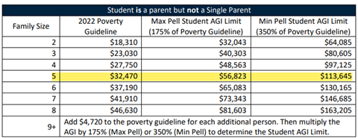
If it seems as though an applicant may not qualify for a maximum or minimum Pell Grant for the 2024-25 award year based on the Look-Up Tables, don’t despair. They may still qualify through the SAI calculation. Other factors that may affect a student’s amount of Pell Grant received include enrollment status, lifetime Pell limits, and cost of attendance.
Overall, these Look-Up Tables not only allow applicants to better understand the eligibility process for receiving a Pell Grant, they also demonstrate that more students will qualify for the award. By thoroughly analyzing each of the factors that play a significant role in calculating an applicant’s eligibility, students can best predict how much of the award they can expect to receive.

