Title I, Part A
Right to Ask for Teacher’s and Paraeducator’s Qualifications

11/4/2022

Dear Parents,

In compliance with the requirements of the Every Student Succeeds Act (ESSA), Lidgerwood would like to inform you that you may request information about the professional qualifications of your student’s teacher(s) or instructional paraprofessional(s) at any time.
- The following information may be requested for teacher(s):
- Whether the teacher has met Washington teacher certification requirements for the grade level and subject areas in which the teacher provides instruction.
- Whether the teacher is teaching under an emergency or other provisional status through which Washington qualifications or certification criteria have been waived.
- The college major and any graduate certification or degree held by the teacher.
- Whether the student is provided services by paraprofessionals, and if so, their qualifications.
- The following information may be requested for instructional paraprofessional(s):
Paraprofessionals must work under the supervision of a certiﬁed teacher. In schools that operate a schoolwide program, all paraprofessionals must meet professional qualiﬁcations. In a Targeted Assistance program, any paraprofessional who is the direct supervision of a certificated teacher must meet the professional qualifications.
Paraeducators can provide a copy of their high school diploma — transcripts are not necessary. Schools that operate a Title I, Part A program must have a high school diploma or GED and completed the following:
- Completed at least two years of study at an institution of higher education; or
- Obtained an associate’s or higher degree; or
- Pass the ETS ParaPro Assessment. The assessment measures skills, and content knowledge related to reading, writing and math;
- Completed previously the apprenticeship requirements and must present a journeycard or certificate. The portfolio and apprenticeships are no longer offered for enrollment; however, the Office of Superintendent of Public Instruction (OSPI) will continue to honor this pathway.

If you wish to request information concerning your child’s teacher’s and instructional paraprofessional’s qualification, please contact Steve Barnes at 509-354-3225

Sincerely,
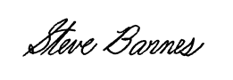
Steve Barnes
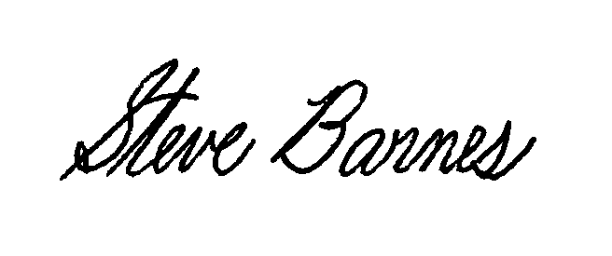
Lidgerwood Principal

