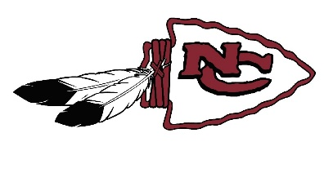
VARSITY LETTER REQUIREMENTS
To earn a varsity letter in Football at North Central High School a player must meet the following criteria.
A. You must attend all practices and games. If you cannot be at a practice/game, you must clear your absence with the head coach. If you are injured, you are still required to attend all practices and games if you are physically able. Again, you must clear your absence with the head coach.
B. To earn a varsity letter in Football, a player must participate in at least one play in nine different quarters during the season. Seniors who have been part of our Football program for the last three years who fall short on nine quarters may letter with the “good standing” with your coaches and teammates.
C. If you are suspended for disciplinary reasons, you are required to practice in all practices, unless you have been permanently dismissed from the team. If you played enough to earn a letter prior to suspension, you will lose your letter, or be dismissed from the team. These decisions will be made by our school administration and football coaching staff.

